DS 6373: Time Series: Unit 2 HW Solutions

Below are the homework (HW) problems for this Unit. You do not need to submit the solutions rather double check your solutions to the solutions posted. Solutions will be posted to the Wall a few days after the release of the HW. This is intended to let the student think about the problem and attempt it without the temptation to first look at the solution. Please write any questions to the Wall or in an email to myself and/or bring them up during office hours or even in the next Live Session. Remember that the concepts covered below are fundamental to the course and are fair game for the midterm and final.

Have a blast!

Problems from the Textbook:

1.5

1.6 d

Solutions:

1.5

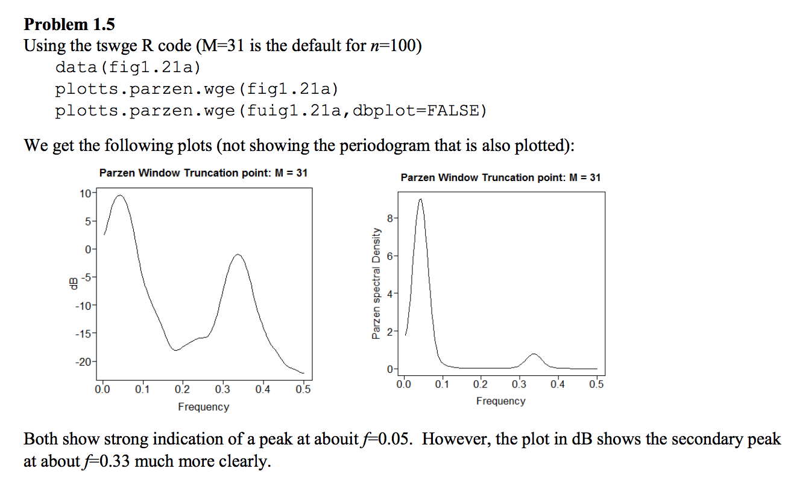

1.6

